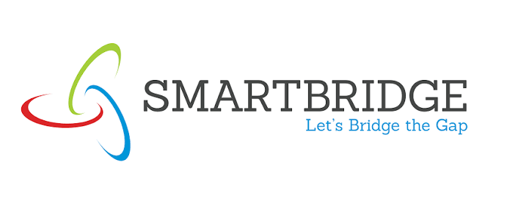 Problem-Solution Fit 
Date | 15 March 2026
Team ID | 6ab4cdb46603573ccfb546d2
Project Name | AI FAQ Assistant API
Maximum Marks | 5 Marks

Problem-Solution Fit Canvas:
Use the framework below to ensure your proposed solution accurately addresses the root causes, behaviors, and limitations of your target audience. Fill out the canvas in the respective boxes just like the original visual template.

1. CUSTOMER  SEGMENT(S) [CS]  Students, staff, or general users who need quick FAQ information and AI-assisted answers. | 6. CUSTOMER  LIMITATIONS  EG. BUDGET, DEVICES  [CL]  Requires internet access, a browser/API client, and basic digital skills. Availability of an API service may be a limitation. | 5. AVAILABLE  SOLUTIONS  PROS & CONS [AS]  Manual FAQ pages and static FAQ systems: easy to use but limited in search, updating, and AI-assisted answers.
2. PROBLEMS / PAINS  + ITS FREQUENCY [PR]  Finding relevant FAQs takes time; answers may be difficult to organize, search, create, or update. Occurs whenever users need information. | 9. PROBLEM ROOT /  CAUSE [RC]  FAQs are scattered or manually maintained, with no centralized AI-assisted process for generating and answering FAQ content. | 7. BEHAVIOR  + ITS INTENSITY [BE]  Users search FAQs, submit questions, and use available answers. Intensity increases when an answer is urgent or unavailable.
3. TRIGGERS TO ACT  [TR]  Need for a quick answer, repeated questions, or difficulty finding an existing FAQ. | 10. YOUR SOLUTION  [SL]  A REST API for secure FAQ management with search, JWT authentication, MongoDB storage, and Gemini AI assistance. | 8. CHANNELS OF  BEHAVIOR [CH]  ONLINE  API / Postman / web-based access  OFFLINE  Direct staff/manual support
4. EMOTIONS  BEFORE / AFTER [EM]  Before: frustrated or delayed when searching for information.  After: quicker access to organized FAQs and AI-assisted answers. | Solution focus  Secure FAQ management + AI-assisted answers.

